In the name of God

Amir Basiri Parsa
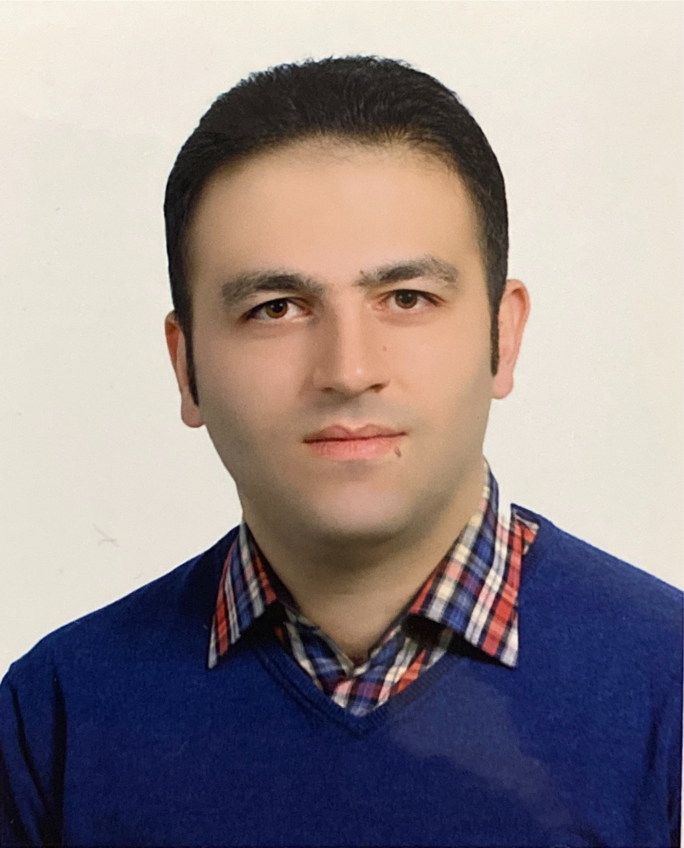
Address: Hamedan University of Technology, Shahid Fahmideh.St, Hamedan, IRAN.
Phone (Home): +98(81)38411444
Cell phone: -
E-mail: amirbparsa@hut.ac.ir, amirbparsa@yahoo.com
GoogleScholar: https://scholar.google.com/citations?user=yk9lqyUAAAAJ&hl=en
Researchgate: https://www.researchgate.net/profile/Amir-Basiri-Parsa
Date Of Birth: August, 19, 1984
Place Of Birth: Hamedan, Iran

EDUCATION

Phd
Mechanical Engineering- Energy Conversion,
September 2011-2017
Department of Mechanical Eng., Bu-Ali Sina University, Hamedan, Iran.
Thesis: “Heat Transfer Enhancement of Nanofluids through Control of Thermal Dispersion effects in a Channel Filled with a Saturated Porous Media”
GPA: 17.20/20

M.Sc
Mechanical Engineering- Energy Conversion,
September 2008 - 2010
Department of Mechanical Eng., Bu-Ali Sina University, Hamedan, Iran.
Thesis: “Investigation of boundary-layer problems with magnetohydrodynamics effects”
GPA: 17.33/20

Mechanical Engineering- Heat transfer and fluid,
September 2003 - 2007
Department of Mechanical Engineering, Bu-Ali Sina University, Hamedan, Iran.
Thesis: “Design and manufacturing of musical water fountain”
GPA: 15.64/20

B.Sc

Diploma
Aref High School, Hamedan, Iran.
September 1998 –2002
GPA: 18.75/20

ACTIVITIES AND ACADEMIC TITLES

- Author of 32 ISI papers
- The top student of Iran in the research section (2012)
- The top student of Bu-Ali Sina University (2010, 2012, 2013)
- The top researcher of Bu-Ali Sina University (2010, 2012)
- The top researcher of Islamic Azad University (2015, 2016)
- The bachelor's top student
- The master's top student
- The PhD’s top student
- Member of the Iran's National Elites Foundation (2008-2021)
- The member of IMSI
- The member of center for talent innovation
- The head of aerospace research institute of Bu-Ali Sina university (2005-2008)
- The head of scientific community of mechanical engineering in Bu-Ali Sina university (2005-2007)
- The editor of sport service of ISNA (2003-2007)

Documents and certificates

- Graduation of second order degree of CNC course in national technical and professional organization (2007)
- Graduation of first order degree of pneumatic course in national technical and professional organization (2008)
- Certificate of die casting
- Certificate of ultrasonic test

RESERCH INTEREST

- Computational Fluid Dynamics (CFD)
- Analytical solution of boundary-layer problems
- Heat transfer
- Energy and exergy analysis of thermodynamic systems
- Combustion chambers
- Artificial neural networks
- Power plant optimization
- Analysis of turbomachines
- Air condition
- Porous media and nanofluids

PUBLICATIONS

The Journal Papers
Condition | Journal |  | Title | Number
- Published | - Energy |  | - Parametric analysis and optimization of regenerative Clausius and organic Rankine cycles with two feedwater heaters using artificial bees colony and artificial neural network | - 1
- Published | - Computers in Biology and Medicine |  | - Semi-computational simulation of magneto hemodynamic flow in a semi porous channel using optimal homotopy and differential transform methods | - 2
- Published | - Heat Transfer - Asian Research |  | - Analytical Modeling of heat convection in magnetized micropolar fluid by using modified differential transform method | - 3
- Published | - Part A: Journal of Power and Energy |  | - Analysis and optimization of a transcritical power cycle with regenerator using artificial neural networks and genetic algorithms | - 4
- Published | - Energy |  | - Parametric study and optimization of a Bryton and inverse Bryton cycle using artificial neural network and artificial bees colony | - 5
- Published | - Heat Transfer—Asian Research |  | - MHD boundary‐layer flow over a stretching surface with internal heat generation or absorption | - 6
- Published | - Heat Transfer - Asian Research |  | - Analytical Solution and Numerical Simulation for  - One-Dimensional Steady Nonlinear Heat Conduction in a Longitudinal Radial Fin with Various Profiles | - 7
- Published | - Heat Transfer - Asian Research |  | - Solving of boundary-layer equations with transpiration effects, government on a vertical permeable cylinder by using modified differential transform method | - 8
- Published | - Mathematical Problems in Engineering |  | Lie Group Solution for Free Convective Flow of a Nanofluid Past a Chemically Reacting Horizontal Plate in a Porous Media | - 9
- Published | - Walailak Journal |  | - Analytical and Numerical Solutions of Vapor Flow in a Flat Plate Heat Pipe | - 10
- Published | - Abstract and Applied Analysis |  | - MHD Natural Convection with Convective Surface Boundary Condition over a flat plate | - 11
- Published | - Applied Bionics and Biomechanics |  | - Parametric analysis of entropy generation in magneto-hemodynamic flow in a semi-porous channel with OHAM and DTM | - 12
- Published | - Applied Mathematics and Mechanics |  | - Analytical solution of MHD flow in the boundary-layer over a stretching surface with internal heat generation or absorption | 13
- Published | - Journal of Mechanical Science and Technology |  | - Analytical solution of non-Fourier and Fourier bioheat transfer analysis during laser irradiation of skin tissue | 14
- Published | - Computers in Biology and Medicine |  | - Semi-computational simulation of magneto hemodynamic flow in a semi porous channel using optimal homotopy and differential transform methods | 15
- Published | - International Journal of Computational Methods |  | - The modified Differential Transform Method for solving off-centered stagnation flow towards a rotating disc | 16
- Accepted-Inpress | - Journal of heat transfer |  | Scaling Transformations for Mass Transfer Effects on MHD Natural Convection with Convective Surface Boundary Condition | 17
Published | Journal of Thermal Science |  | Entropy Generation Analysis Of The Revised Cheng–Minkowycz Problem for Natural Convective Boundary Layer Flow Of Nanofluid In A Porous medium Using An Analytical Method | 18
Published | Computational Methods for Differential Equations |  | Analytical solution of MHD flow and heat transfer over a permeable nonlinearly stretching sheet in a porous medium filled by a nanofluid | 19
Published | International Journal of Exergy |  | Exergetic Optimization of a Multi-Stage Compression Transcritical Refrigeration Cycle | 20
Published | Thermal Science |  | Numerical analysis of forced convection heat transfer from two tandem circular cylinders embedded in a porous medium | 21
Published | Progress in Computational Fluid Dynamics An International Journal |  | Group Analysis and Numerical Solution of Slip Flow of a Nanofluid in Porous Media with Heat Transfer | 22
Published | Thermal Science |  | Numerical study of forced convection heat transfer over three cylinders in staggered arrangement immersed in porous media | 23
Published | Heat Transfer - Asian Research |  | Analysis of MHD micropolar nanoﬂuid ﬂow and heat transfer between a porous plate and a nonporous plate ﬁlled with porous medium | 24
Published | Frontiers in Heat and Mass Transfer |  | MHD nanofluid flow with viscous dissipation and joule heating through a permeable channel | 25
Published | Quaestiones Mathematicae |  | Nanofluid Flow and Heat Transfer in a Brinkman Porous  Channel with Variable Porosity | 26
Published | Results in Physics |  | A new numerical method for investigation of thermophoresis and Brownian motion effects on MHD nanoﬂuid ﬂow and heat transfer between parallel plates partially ﬁlled with a porous medium | 27
Published | Computational Methods for Diﬀerential Equations |  | Analytical solution of MHD ﬂow and heat transfer over a permeable nonlinearly stretching sheet in a porous medium ﬁlled by a nanoﬂuid | 28
Accepted | Applied and Computational Sciences in Mechanics |  | Numerical and Analytical Investigation of Thermal Dispersion and Nanoparticles’s Distribution functions Effects on Heat Transfer of Nanofluid flow inside a Channel | 29
Accepted | Journal of Mechanical Engineering, Tabriz University |  | Numerical solution of Force Convection Heat Transfer of Nanofluid between parallel plates and Investigation of Parabolic and Exponential function for NanoParticle’s Distribution | 30
Accepted | Alexandria Engineering Journal |  | Nanofluid Flow and Heat Transfer using Buongiorno Model in a Brinkman Porous Channel with Variable Porosity and nanoparticles partial injection | 31
Accepted | Advanced Powder Technology |  | Analytical Investigation of magnetohydrodynamic nanofluid flow through a porous channel with hydrodynamic slip and Convective boundary conditions in the presence of viscous dissipation and Joule heating | 32
The Selected of Conference Papers
Condition |  | Conference | Title | Number
- Presented |  | - FD 2010 Shiraz, Iran (September 21-23, 2010). | - Application of modified differential transform method for solving MHD boundary-layer equations in a micropolar fluid at a stretching surface | - 1
- Presented |  | - INCOTEE 2011- Kalasalingam India, (March 24-26, 2011). | - Application Of Homotopy Analysis Method To Determine The Fin Efficiency With Variable Cross-Section With Temperature-Dependent Thermal Conductivity | - 2
- Presented |  | - ISME 2011, Tehran, Iran, (May 12-14, 2011). | - Investigation of the stress and heat damage of the skin in the heating process using the non-Fourier heat transfer equation | - 3
- Presented |  | - ISME 2012- Birjand, Iran, (May 18-20, 2012). | - Numerical study of laser heat transfer in a three-dimensional microfilm with dual phase delay equations | - 4
- Presented |  | - CONV-14: Int. Symp. on Convective Heat and Mass Transfer, Turkey,  - (June 8-13, 2014) | - Analytical approximatio and numerical solution of electrically conducting fluid flow over a stretched with the nonlinear velocity in a porous medium filled by a nanofluid | - 5

Projects, Job Experiences and Activities

- Designer of air conditioning systems (chillers and air handling unit) (2008-2021)
- Maintenance expert of compressor (2011-2021)
- Maintenance expert of Power plant steam turbine (2011-2014)
- Supervisor engineer in Iran Standard & Quality Inspection Corporation (2010 2012)
- The member of Iranian construction engineering organization (2012-2021)
- Designer and supervisor engineer for gas piping project (2005-2010)
- Designer and supervisor of high-pressure gas pipeline for project of Vian steel complex (2009)
- Supervisor engineer of equipment installation for Vian steel complex project (2009)
- Supervisor engineer of laboratory equipment installation for Islamic Azad university (2009)
- Design and optimization of energy consumption for industrial parks (2017)
- Design and construction of water boilers (2007-2013)

Teaching Experiences

- Bachelor thesis supervision in Hamedan University of Technology.
- Bachelor thesis supervision in Bu-Ali Sina University.
- Master thesis Consultation in Bu-Ali Sina University.
- Teacher of following courses in mechanical engineering department of Hamedan University of Technology and Bu-Ali Sina University:
- Fluids mechanic 1
- Fluids mechanic 2
- Thermodynamics 1
- Heat transfer
- Basics of computer programming
- Power plants
- Turbomachinery
- Water distribution systems
- Teacher of following courses in engineering faculty of Malayer University and Islamic Azad University.
- Fluids mechanic 1
- Fluids mechanic 2
- Thermodynamics 1
- Heat transfer
- Power plants
- Turbomachinery
- Water distribution systems
- Designing of Refrigeration systems

COMPUTER SKILLS

- Mathematica (highly skilled)
- Ansys (Fluent & CFX)
- Maple (highly skilled)
- Programming Language: Fortran (highly skilled)
- Auto Cad (highly skilled)
- Matlab (skilled)
- Gambit and Fluent (skilled)
- Mechanical desktop (Familiar)
- MS Office (Word, Excel, Power point)

LANGUAGES

- Farsi: (mother tongue)
- English: (skilled)

OTHER ACTIVITIES

- Member of the Iran's National Elites Foundation (2008-2021)
- Secretary of the Scientific Association of Mechanical Engineering, Bu Ali Sina University (2005-2007)
- 2nd place of student football games with Buali-sina university team (2011)
- Winner of state football games with high school team (2000)
- 3rd place of young man sprint games of Hamedan (1998)
- Climbing up some of highest mountains in iran with Homa climbing group.

